Fall 2020 Hybrid Class Schedules: Information and a Brief How To

As you are likely aware, we have been making adjustments to the Fall 2020 course schedule in an effort to offer you choices and flexibility, as well as provide for social distancing in your in-person courses. Over the past few weeks, approximately 900 course sections have moved online. Today we are making schedules for about 1,275 hybrid sections appear in UNCGenie. These courses will be delivered using a mix of in-person and online instruction. As a result, many have new meeting patterns I want you to be aware of. If you are enrolled in a hybrid course, you may be able to choose which meeting pattern for that course best fits your schedule.

How Do I Know If I’m In A Hybrid Course?
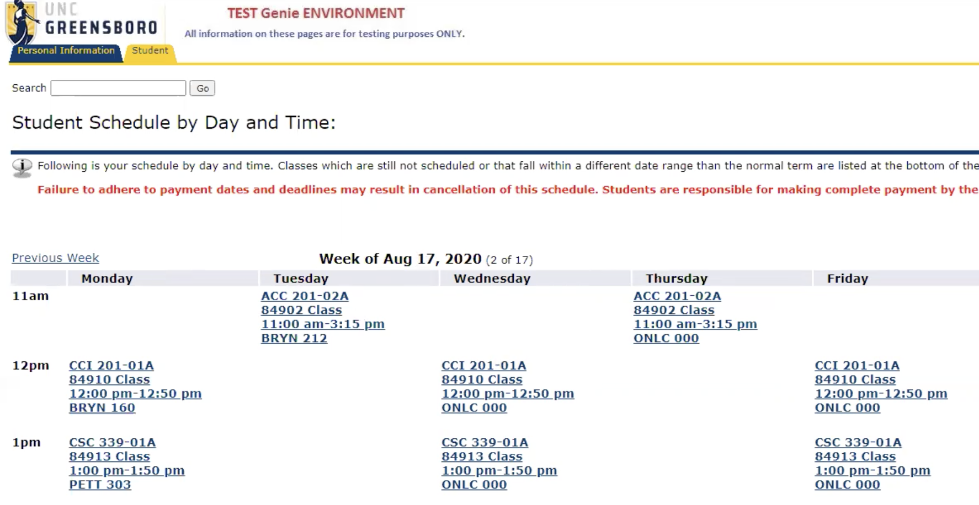
Genie gives you the option to view your schedule by day and time. If you go to your schedule for the first week of class and see something like the sample image below, you are enrolled in at least one hybrid course. The highlighted hypothetical course, ACC 201-02A, is hybrid. For this student, it meets in person on Tuesdays and online (ONLC 000) on Thursdays. Notice that it has a section letter. That’s a tip that in addition to ACC 201-02A, there is also an ACC 201-02B, which likely meets on the opposite pattern in this hypothetical scenario. (Students were randomly assigned to hybrid sections.)

How Do I Know What The Other Meeting Patterns Are For My Hybrid Course?
If you visit Genie’s add/drop page, and search for the courses you’re enrolled in, you will see something like the sample list below, which shows all the Fall 2020 sections of ACC 201 in this hypothetical scenario. (Don’t try to add the sections listed here; they are not real. In this sample you can see the A and B sections of the same course, which meet in opposite patterns, as indicated in the Location field. Note that this is just one example. Several different meeting patterns are possible, especially for MWF courses.

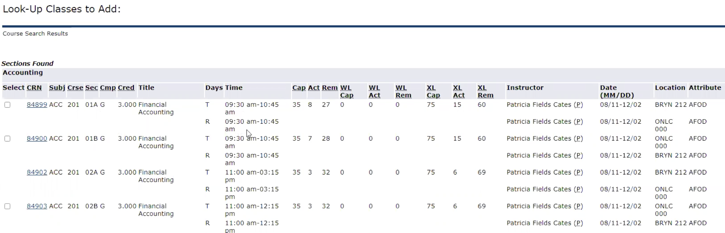
B
A

How Do I Change To A Different Meeting Pattern?
All you have to do change meeting patterns is drop the section you’re enrolled in and add the other. Note, however, that because of social distancing, you will only be able to do this if there are seats available. For this same reason, we cannot add students to full sections.

What Should I Do If I Like The Schedule I Have?
If you’re in a hybrid course like the examples above, and have been randomly assigned to a meeting pattern that suits your schedule, you don’t have to do anything else.

Who Do I Talk To If I Need Help Understanding or Adjusting My Schedule?
Your academic advisor can help you think through your options, or you can contact the advising center in your home school or college. You will find links to these here. The Students First Office maintains a page that links students to the advising centers in all of the schools and colleges. You can also send an email to Dean Hamilton at ugdean@uncg.edu.

